Introduction to week6

# LSTM + LSTM, 2 hidden layers

This week, we use the model of 2 hidden layers: LSTM + LSTM, the code change:

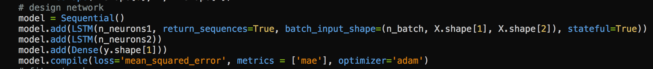

I made several 50-epochs’training and validating, using different combination of hidden layer numbers, and got the following validation result:













Next, we choose several hidden layers’ combination with better performance, and made several 500 epochs’ training and validating:









I chose 12 and 4 as the number of neurons of two hidden LSTM layer, and made 7-day forecast from Feb 5 to Feb 12, and made comparison to the methods I used before:

First, we already know single LSTM hidden layer’s picture:



It could be seen that, none of the peaks was captured by the forecast.

Next, I plot 7-day forecast with LSTM + Dense two hidden layers:



We noticed that, none of the peaks was captured.

Next, I plot 7-day forecast using LSTM + LSTM two hidden layers:



This time, the second peak was accurately captured!

In all these forecasts, I kept the original data intact.

But Why the first peak was not captured? Maybe the reason resides in the corrupted source data (and thus the 7-day cycle was ruined). I noticed that about 10 days’ information was missing in the original data, and 3 day’s information was duplicated.

Next week I will try repair the data and make forecast with 2 LSTM hidden layers.